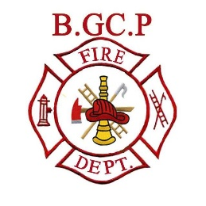

BRYSON, ILE-DU-GRAND-CALUMET AND PORTAGE-DU-FORT
OPEN AIR BURN PERMIT

Name of Applicant ______________________ Phone # ________________________
Address _______________________________ Postal Code _____________________
Owner of Property: Yes / No Applicant is 18 years of age or older
Signature of owner if granting permission ___________________________________________
Location of open burn if different from above ________________________________________
Type of Extinguishments on location: Class “A” Extinguisher - Garden Hose

DAILY PERMIT - Please provide date and approx. time of burn __________________________
WEEKEND PERMIT – Dates and approx. time of burns __________________________

The applicant agrees to comply with the provisions of By-Law and agrees to
assume all responsibility for any damages occurring from the fire for which this
permit is issued.
Permit valid for three (1) year from date of issue. Payment is due upon issue of
permit, cheque or cash only.

Date of issue __________________
_____________________________ _____________________________
Signature of Applicant Fire Prevention Officer/Chief Fire Official

Permit cost:
Daily permit: 10.00$
Weekend permit: 25.00$

